AI WeatherWise — Project Document

1.Brainstorming & Ideation Phase
Concept: A RESTful backend platform, “AI WeatherWise”, that delivers real-time weather metrics and pairs them with Google Gemini AI to produce natural-language summaries and personalized recommendations.
Core Idea: Combine a standard weather-data API (favorite locations, live metrics) with generative AI that turns raw conditions into human-readable insights and activity/clothing suggestions.
Target Users: Travel enthusiasts and everyday users tracking weather across multiple cities, plus developers/admins who monitor the platform.
Key Differentiators: AI-generated natural-language summaries, personalized recommendations, secure cross-device preference sync, and a resilient fallback mode that keeps the API functional even without external API keys.

Possible Features Brainstormed
- CRUD management of favorite weather locations
- Real-time weather metric retrieval per location
- AI-generated natural-language weather summaries
- Personalized activity and clothing recommendations
- Secure JWT-based authentication and preference sync
- Fallback mode when external AI/weather API keys are unavailable

2. Requirement Analysis Phase
Functional Requirements
- User authentication & role management (Admin, Registered User)
- CRUD operations for favorite locations
- Real-time weather retrieval endpoint (OpenWeatherMap integration)
- AI insight endpoints for summaries & recommendations (Gemini)
- Public weather endpoints for unauthenticated access
- Admin endpoints for API health and user monitoring

Non-Functional Requirements
- Security (JWT auth, bcrypt password hashing, input sanitization)
- Reliability (fallback mode without external API keys)
- Performance (low-latency weather and AI responses)
- Cross-platform support (Windows, macOS, Linux)

Tools/Tech Considered: Node.js, Express.js, MongoDB with Mongoose ODM, Google Gemini AI
SDK (@google/generative-ai), bcryptjs, JSON Web Tokens, dotenv, multer, Postman.

3.Project Design Phase

Architecture: MVC pattern decoupling business logic from data management: a Controller layer orchestrates weather fetching and AI insight generation, while the Model layer manages User and Location entities.
Database Design: Entities — User (profile, credentials, role) and Location (city, country, owner reference), related One-to-Many: a user can save multiple favorite locations.
API Design: RESTful endpoints for authentication, favorite-location management, weather retrieval, and AI-driven insights.
AI Integration Design: A controller-level integration routes weather data to Google Gemini, generating summaries and recommendations from live temperature and conditions.
Security Design: JWT-based authentication, bcrypt password hashing, role-based access control (Admin vs. Registered User), and payload sanitization against XSS and NoSQL injection.
Diagrams Needed: System/technical architecture diagram, entity-relationship (ER) diagram, and user-flow sequence diagram.

Data Flow Diagram (DFD)

The DFD shows how data moves between the user and the stored data of just listing the design points.

Level 1 — Detailed DFD

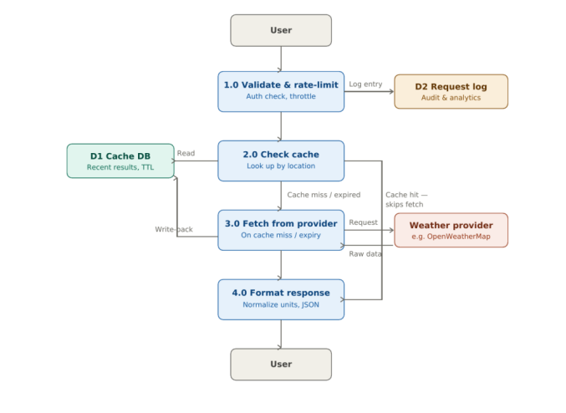

Figure: Level 1 DFD Processes, data stores, and external entities, with the cache paths show separately.

4.Project Planning Phase

Team Roles: Backend Developer(s), AI Integration Engineer, QA Tester, Technical Write
Risk Management: Dependency on third-party weather/AI API availability and rate limits, latency in AI response generation, and secure handling of API credentials.
Tools: Postman for API verification, Visual Studio Code as the IDE, Git for version control.

5.Project Development Phase
- Set up the project folder and initialize with npm init
- Install core dependencies: express, mongoose, bcryptjs, jsonwebtoken, cors, dotenv, multer, @google/genai
- Configure environment variables (PORT, MONGO_URI, JWT_SECRET, GEMINI_API_KEY)
- Establish the MongoDB connection via Mongoose before handling requests
- Define Mongoose schemas for User and Location entities
- Build the index.js entry point: initialize Express, load middleware, register routes, start the server
- Implement authentication (JWT issuing/validation, bcrypt hashing) and role-based route guarding
- Build weather-retrieval and Gemini-powered recommendation endpoints
- Apply sanitization middleware to guard against XSS and NoSQL injection

6. Project Testing Phase
Unit Testing: Individual schema, model, and endpoint-level tests.
Integration Testing: Authentication + weather retrieval + AI service + MongoDB interactions.
API Testing: Register, Login, Weather, and Recommendation endpoints verified via Postman.
Security Testing: Auth bypass checks, input validation, and sanitization checks.
UAT (User Acceptance Testing): End-to-end validation of the user flow — register/login, save a favorite city, fetch weather, and request an AI-driven insight.

7. Project Documentation Phase
API Documentation: Endpoint reference verified through Postman collections.
Technical Documentation: Architecture overview (MVC breakdown), Mongoose schema definitions, and environment/setup guide.
User Guide: How to manage favorite locations, fetch live weather, and request AI-generated summaries and recommendations.
Change Log: Version history maintained across releases, alongside recorded demo and API-testing videos.

8. Project Demonstration Phase
- Prepare a recorded demo walkthrough of key API endpoints (Register, Login, Weather, Recommendation) via Postman
- Showcase the AI-driven weather summary and recommendation flow end-to-end
- Present the backend demo and API-testing videos, plus the shared code repository
- Q&A / feedback collection for the next iteration
This document provides a concise, phase-wise overview. Each section can be expanded into a detailed sub-document as the project progresses.

